**Roster (eGrocery) Knowledge Base**

|  |  |
| --- | --- |
| Created by | Deepali Sharma |
| Date |  |

# Introduction

Roster is a leading logistics service company in Finland. They have the widest network coverage in Finland and visit about three million households and companies every day.

Roster has a Grocery delivery business unit and wants to improve its Consumer Experience by providing a real-time order status updates using automated IT system. It provides pickup from Grocery Stores and doorstep delivery to end customers by using GlobalFE’s web and mobile application.

|  |  |
| --- | --- |
| Country | Finland |
| Language (GlobalFE App Mobile and Web UI) | English |
| Language (Order Statuses) | Finnish |
| Staging Account login credentials | Rosttemp_admin |
| Production Account login credentials | Rosterfin_admin |
| GlobalFE App Version | V2 (React Application) |
| Application Link | https://www.rostereye.co/ |

# Basic Flow

The basic workflow of the account is explained with the help of a basic flow chart and the steps mentioned below:

1. The orders are created/pushed through Schedular everyday and assigned to the rider by manual assignment or Auto-routing.
2. Driver starts the route and picks up the grocery items to deliver from the Grocery Store.
3. Driver marks one of the below two options in his/her device:
4. Reached at Customer Location
5. Extra Pickup (Incase he has forgotten to pickup some items, so he will mark "Extra Pickup" and perform pickup again)
6. On reaching at customer location, the driver marks one of the below two options:
7. Delivery Success
8. Delivery Failed
9. If marked as **Delivery Success**, the driver will mark **End Route**.
10. If marked as **Delivery Failed**, the driver marks one of the below two options:
11. Unload (back to Grocery Store) and then mark **End Route**.
12. Reattempt
13. On marking **Reattempt**, the driver will reattempt the delivery and will mark one of the below two options:
14. Delivery Success
15. Delivery Failed

# Order creation

There are mainly three ways to create an order in GlobalFE:

1. Pushing JSON through API
2. Uploading Excel File
3. Add process from Data Store (Customer details are added in Data Store from Rosterer end and a scheduler is used for a specific time and orders are added in GlobalFE through Reverse Connector)

*Note: When there are orders to be created in bulk every day, uploading excel file and setting schedular are preferred for order creation.*

# Main Processes

1. **Groceries Pickup and Deliveries**

Normal order creation, assignment and completion of pickup and delivery task both through Delivery job master "Kauppakassit")

1. **Noja Orders**
2. Order creation through scheduler
3. Noja(spelled as No-ya) orders fetch customer details from Data Store "Suoratoimitukset" and this Data Store contains details about their "**Regular customers**" whom the drivers have to visit daily.
4. Customer details are added by Rosterer Side itself in the DataStore.

## Steps to set Schedular and Noja order creation

1. Go to Settings > Connector Reverse Master > Noja Orders > Add/Delete Schedular > +Set Schedular for Add Process from Data Store (set Finland time)

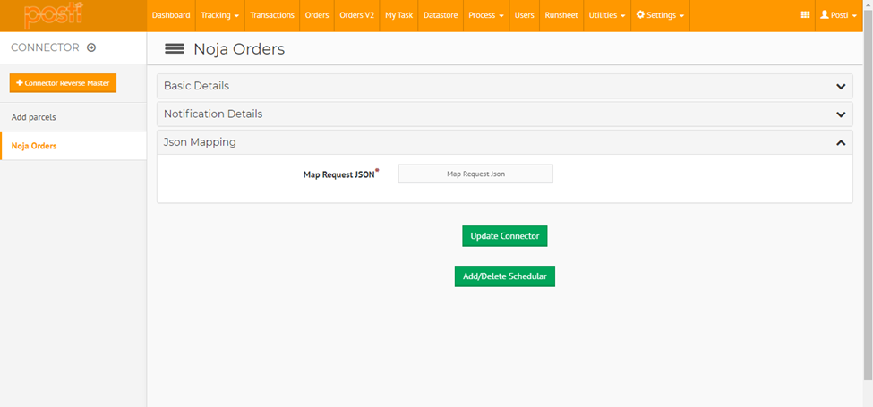

1. Suppose time is set for 14:30(Finland time), the orders will be created for all the entries in the Data Store and orders are visible in Orders V2 to assign.

*Note: Key difference between Manually created orders and Noja orders is that no status events are sent for Noja Orders through Integration Connector.*

## Types of SMS sent to the end customer:

There are mainly three types of SMS sent to the end costumer:

1. At the time of order assignment

*“Dear <customer_name>, your order number <order_number> is assigned to our rider and will be picked up from the Grocery store. You can track you order by the link <URL LINK>.”*

1. When order is pickup up successfully from store

*“Dear <customer_name>, your order number <order_number> is sucessfully picked up from the Grocery Store and the rider is out for delivery. You can track you order by the link <URL LINK>.”*

1. When order is delivered successfully to end customer

*“Dear <customer_name>, your order number <order_number> is delivered successfully. You can rate our rider using the feedback link <URL LINK>.”*

# Repeated Issues

Here is a brief description of the common issues that are reported by the client.

* Slow Printing of Runsheet
* Order not Found from Map
* Auto Routing issue [No Credits Left for Routing]
* Job not Reflecting in Device

## Slow Printing of Runsheet

**Description**: It took too much time to print a Runsheet from GlobalFE web application after giving the Print command. An RCA was created for the issue and was shared with the client.

The Tech Support team and the Development team monitored but did not find any such issue on Production server and the same was conveyed to the client. Later, client reported the same issue again. The teams analyzed and found that the client was performing route assignment (Transaction Creation) + Runsheet print activity with 3-4 Sec. Same was conveyed to the client that it is an expected behavior and there was not delay in Runsheet printing.

### Steps to fix the issue

Refer to the following steps:

1. Check if the Runsheet printing task is slow (by giving the Print command).
2. If slowness is not found and the printing task is completed without delay, then reply to the client that no issue was found at our end.
3. If slowness is found or if the same issue is reported repeatedly, forward the ticket to the Development team.

### Reply to the email

Refer to the below sample reply:

Dear <Name>,

We tried to print Runsheet and were able to open pages as expected. Please let us know if still any user facing issue in printing Runsheet. Also, we request you to kindly check network connectivity of affected users. Please let us know on immediate basis so that we can investigate it further.

## Order not Found from Map

**Description**: While auto routing orders, one address was not found, and the Dispatcher had to manually set the location.

As client already assigned the order manually and no workaround was required, the ticket was marked pending for RCA. The issue was shared with the Development team and an RCA was provided to the client.

**What caused the issue?**

In the RCA, the root cause was that there was extra space in the address, so it was not found in Google Geocoding, and because of it, that order was getting excluded while routing. This minor difference played a big role in Google Geocoding API and particular order was excluded.

### Steps to fix the issue

Refer to the below mentioned steps:

1. Copy the affected parcel’s TN and check if there is any discrepancy in the order address in GlobalFE web application (Orders V2 module).
2. Search the affected parcel’s address in Google maps and check if it is a valid address.
3. Share the issue with the Development team for RCA creation as the client assigned the order manually and no workaround was required.
4. Reply to the client with RCA details.

### Reply to the email

Dear <Name>,

As informed, our development team is working on the issue. The RCA is shared below with the root cause. < RCA link> Do let us know if any further assistance is required. If not, we would request you to allow us for the ticket closure.

## Auto Routing issue [No Credits Left for Routing]

**Description**: The client was not able to Auto Route orders. They received an error that their daily credit limit was consumed.

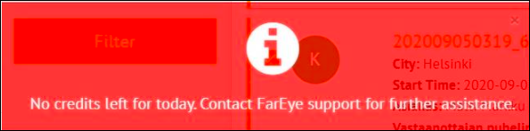

**What caused the issue?**

There is daily credit limit API based on Google geocoding account. The day, the issue was reported, the daily limit for the Google Geo-coding account was consumed.

Every time, a new request to Google Geo-coding was pushed, it got rejected and led to failure in fetching latitude longitude details. Because of this reason, auto routing could not be done.

The issue was shared with the development team and an RCA was provided to the client. As a solution, the daily credit limit was updated.

### Reply to the email

Dear <Name>,

We have updated the auto-routing credits as per your request. You can proceed with the auto-routing for the orders. As of now, we are proceeding with the ticket <#>closure.

## Job not Reflecting in Device

**Description**: Orders were assigned but not getting reflected in Driver’s mobile device. Sometimes this issue is faced by one driver but when the same orders are assigned to another driver, the issue gets resolved. As a solution, unassign the orders and reassign them to another driver.

**What caused the issue?**

The issue occurred because on logout and login for newly added jobs, the server did not send the "tripUpdate" querytype and hence the jobs assigned in logout mode were not moved to Auto Start Trip.

### Steps to fix the issue

Refer to the following steps to fix this issue:

1. Login on GlobalFE EU server https://eu.GlobalFE.com
2. In Process Dump Report under Utilities module, select Process Master > grocery Pickup and Deliveries.

1. In attributes, select **Reference Number** and **Current Flow**.
2. Click **Request for Dump**.

1. In the downloaded **Process Dump Report**excel, check if the current flow of the order is End which means the order is delivered.
2. Reply to the client that the team will investigate the issue and will share the RCA.
3. If the Current flow is of Delivery (Kauppakassit) and the client is still facing the issue, then unassign the orders and reassign them to another user.
4. Share the RCA & JIRA details with the client.

### Reply to the email

Dear <Name>,

We would like to confirm that the above-mentioned issue with support ticket <#> has been escalated to our technical team as this would require additional Developments on our Platform. A corresponding Development request on JIRA (tracking tool) has also been created. Our development team would prioritize this request in the next upcoming sprint.

To track updates on this development request, please visit this link: <JIRA link>>

We are proceeding with the support ticket closure and would request you to refer the above URL for further updates. Thanking you for your kind cooperation.